ASSIGNMENT-8.1
HT NO:2303A51644
Batch No:28
Course:AI Assisted Coding
Task Description 1: (Password Strength Validator – Apply AI in Security Context)
- Task: Apply AI to generate at least 3 assert test cases for is_strong_password(password) and implement the validator function.
Prompt:

Generate at least 3 assert test cases for a Python function is_strong_password(password). Requirements:
  - Minimum 8 characters
  - Must contain uppercase, lowercase, digit, and special character
  - Must not contain spaces
Then implement the function so all test cases pass.
- General Testing
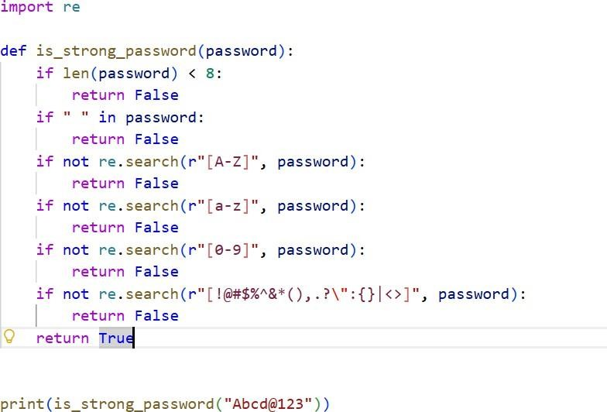

Output:
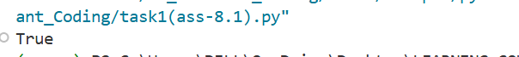
- Assert testing
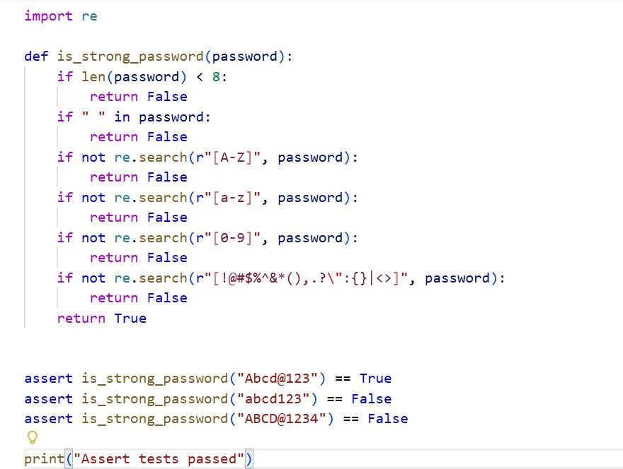
Output:
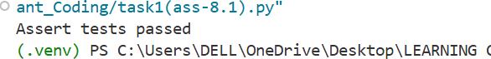

- Unit testing

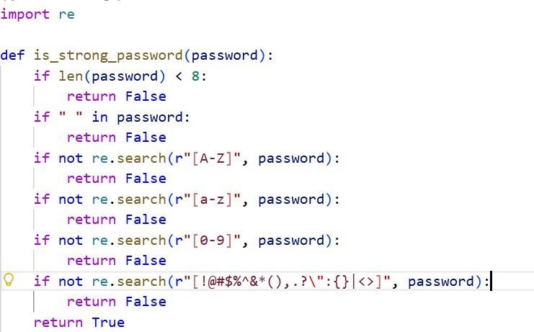

Create Next python file to run Test Cases:
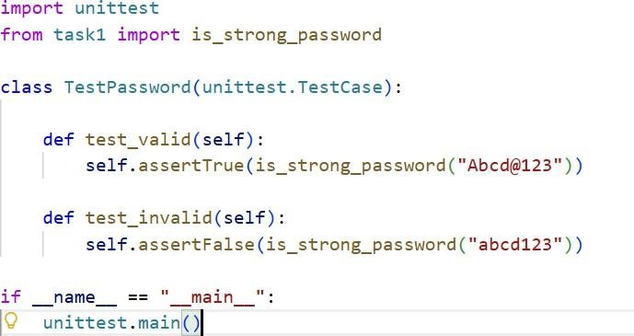

Output:
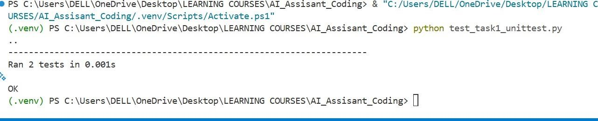
- Pytest and Output:
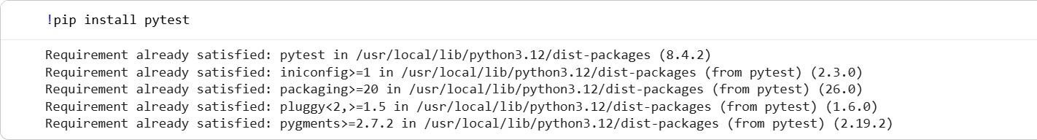
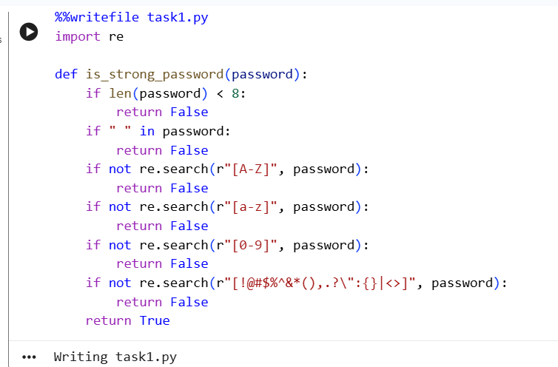

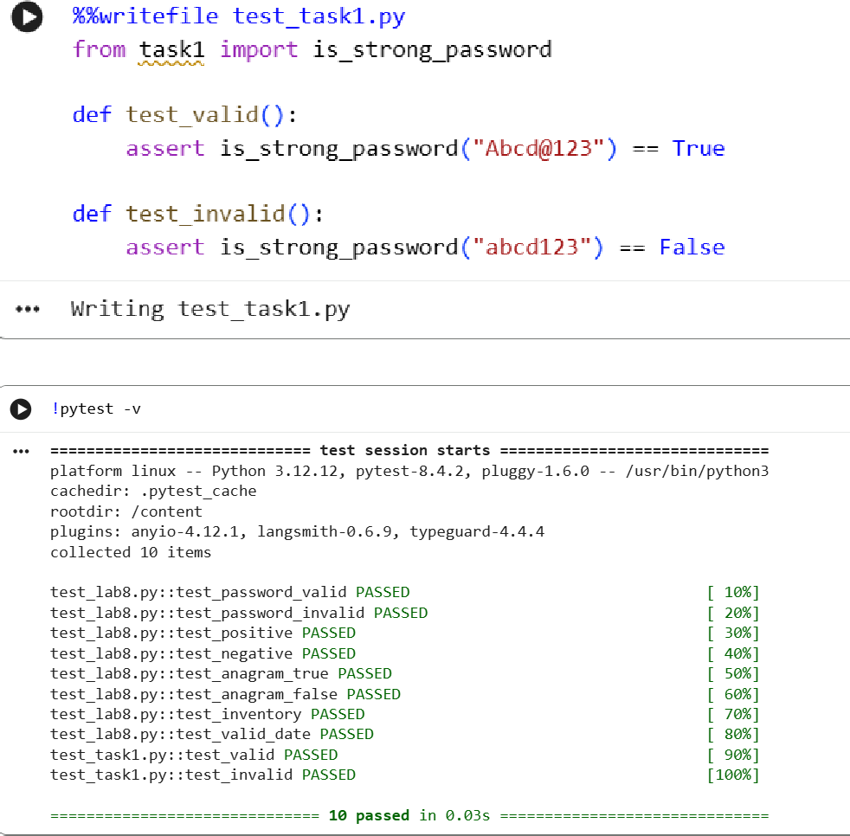

Justification:

This task applies AI in a security context.
  - AI generates edge-case test scenarios.
  - TDD approach ensures validation rules are clearly defined before coding.
  - Improves reliability of password validation.
  - Prevents weak or insecure passwords.
  - Demonstrates input validation and regex handling.

→Shows importance of secure coding
→ Encourages validation before implementation

Task Description 2: (Number Classification with Loops – Apply AI for Edge Case Handling)
- Task: Use AI to generate at least 3 assert test cases for a classify_number(n) function. Implement using loops. Prompt:
Generate at least 3 assert test cases for a function classify_number(n) that:
  - Returns "Positive", "Negative", or "Zero"
  - Handles invalid inputs like strings and None
  - Includes boundary values (-1, 0, 1)
Then implement the function using loops so all tests pass.

- General Testing and Output

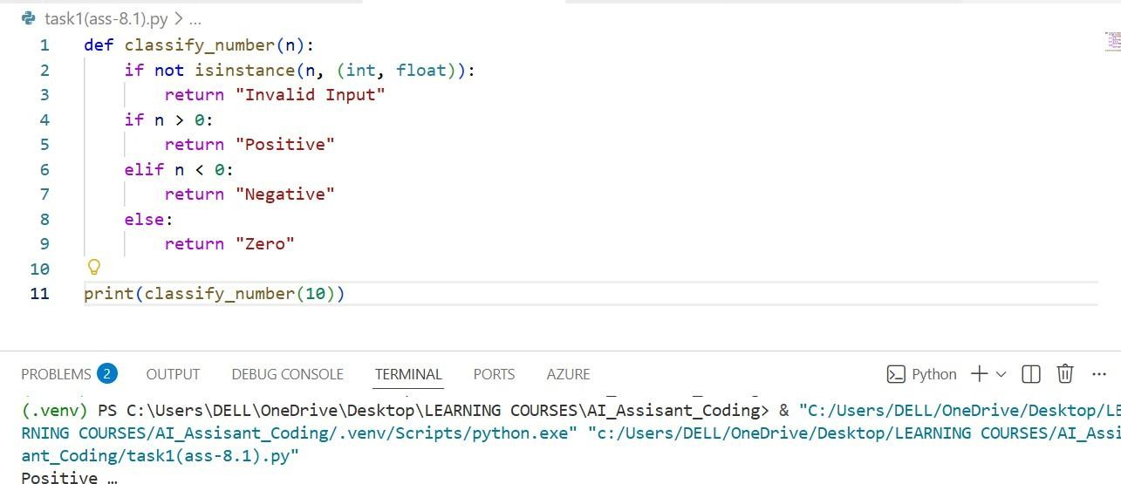
- Assert testing and Output

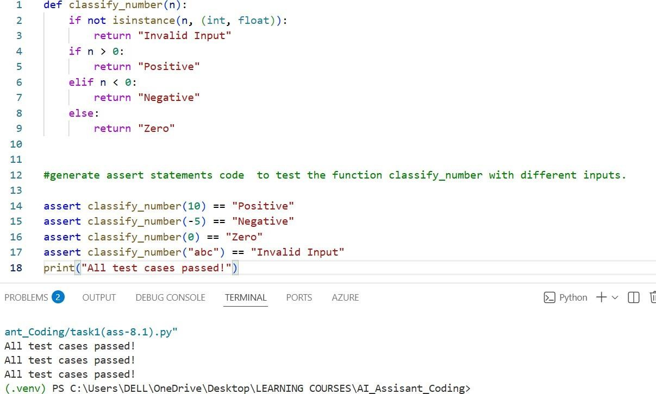

- Unit testing and Output
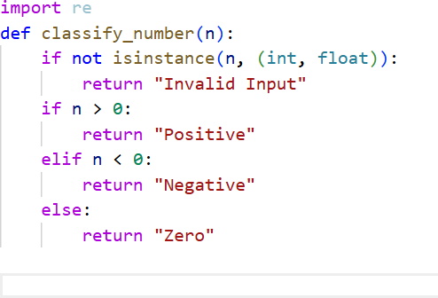

Create Next python file to run Test Cases:

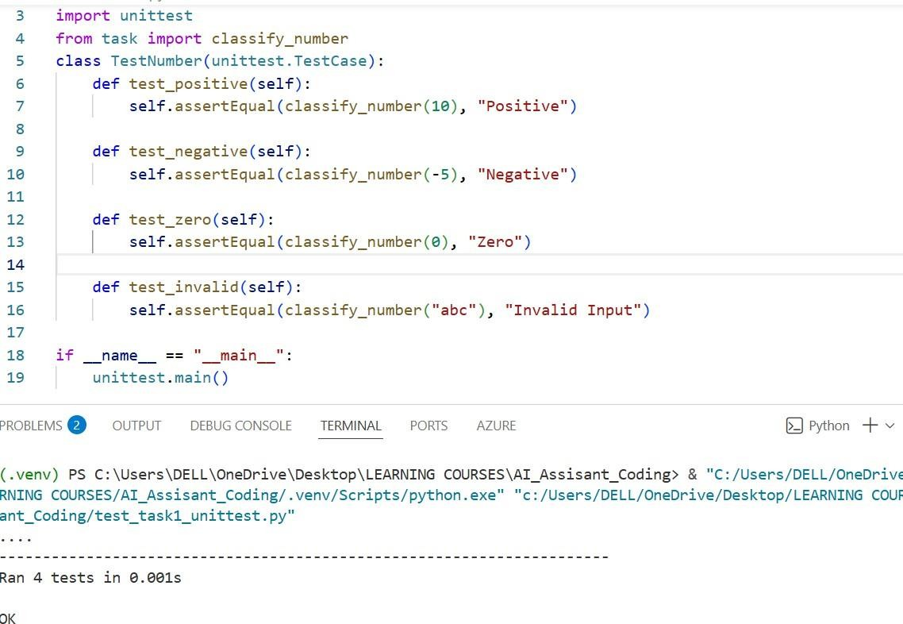
- Pytest and Output:
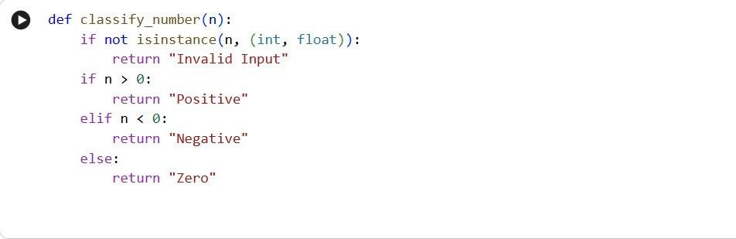
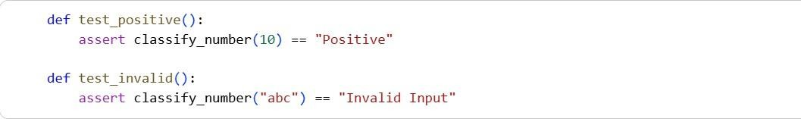

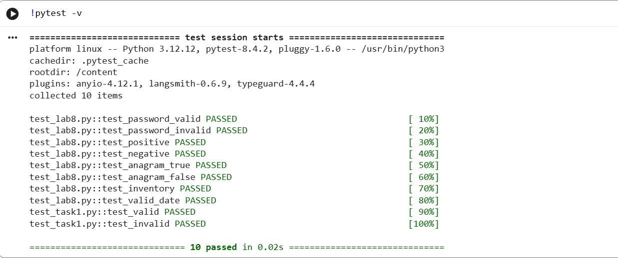

Justification:

This task focuses on edge case handling.

  - AI helps identify boundary conditions.
  - Ensures handling of invalid inputs.
  - Demonstrates defensive programming.
  - Reinforces loop usage and type checking.

→ Encourages robustness

→ Improves error handling

→ Demonstrates TDD validation logic

Task Description 3: (Anagram Checker – Apply AI for String Analysis)
- Task: Use AI to generate at least 3 assert test cases for is_anagram(str1, str2) and implement the function. Prompt:
Generate at least 3 assert test cases for a function is_anagram(str1, str2) that:
  - Ignores case
  - Ignores spaces and punctuation

  - Handles empty strings
Then implement the function so all tests pass.

- General Testing and Output:
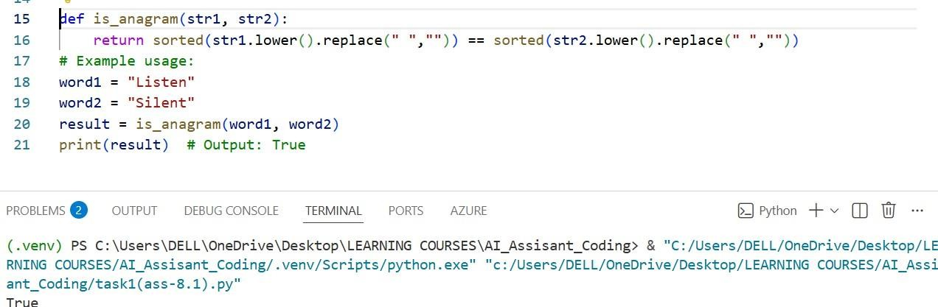

- Assert testing and Output:

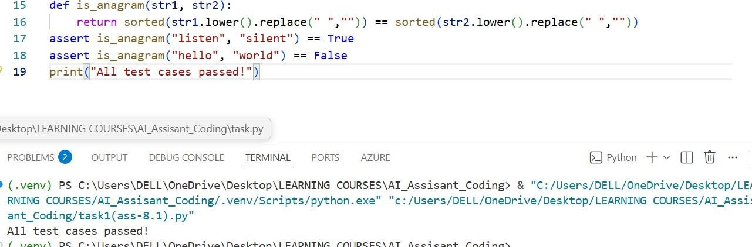
- Unit testing and Output:

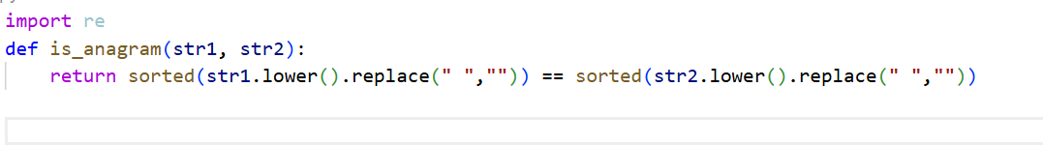

Create Next python file to run Test Cases:
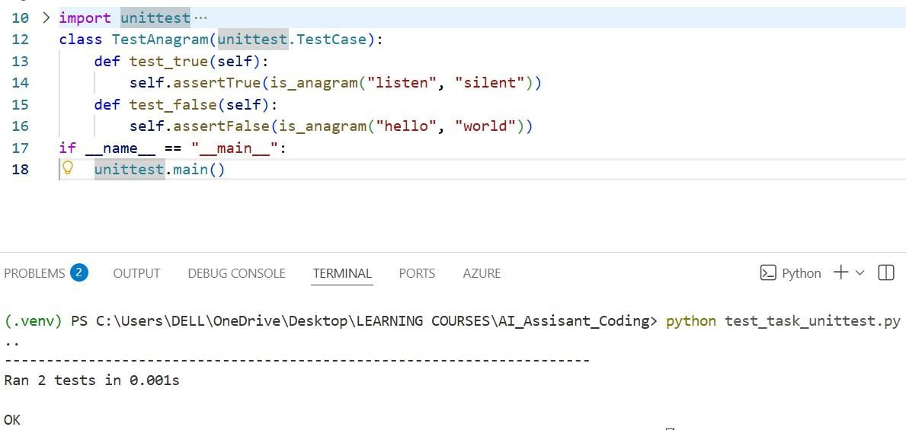
- Pytest and Output:
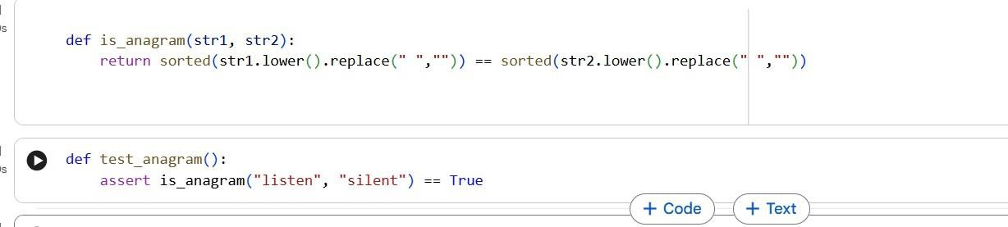

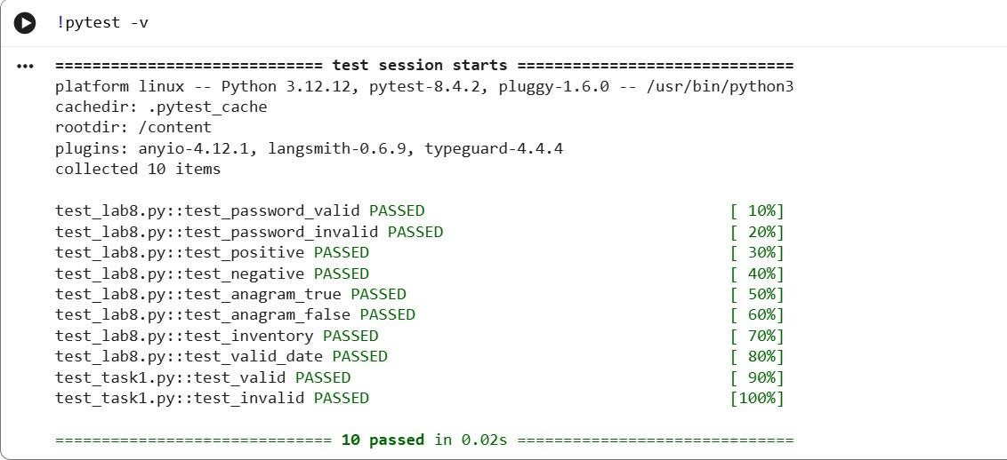

Justification:

This task applies AI for string analysis.

  - AI helps detect tricky test cases.
  - Validates normalization (case folding, filtering).
  - Ensures string preprocessing before comparison.
  - Covers empty and identical cases.

→ Improves text processing logic
→ Demonstrates data cleaning
→ Shows importance of normalization

Task Description 4: (Inventory Class – Apply AI to Simulate Real- World Inventory System)
- Task: Ask AI to generate at least 3 assert-based tests for an Inventory class with stock management.

Prompt:

Generate at least 3 assert-based test cases for an Inventory class that supports:

  - add_item(name, quantity)
  - remove_item(name, quantity)
  - get_stock(name)
Then implement the class so all assertions pass.

- General Testing and Output:
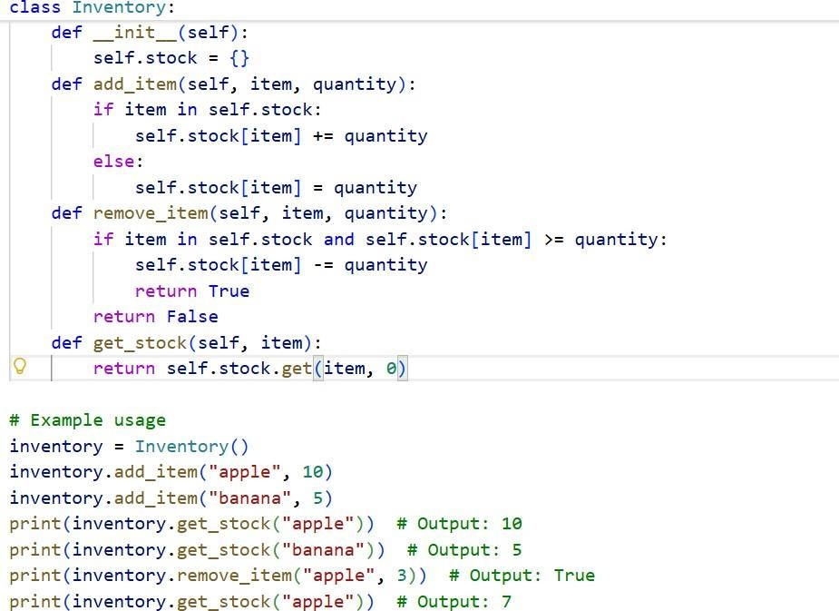

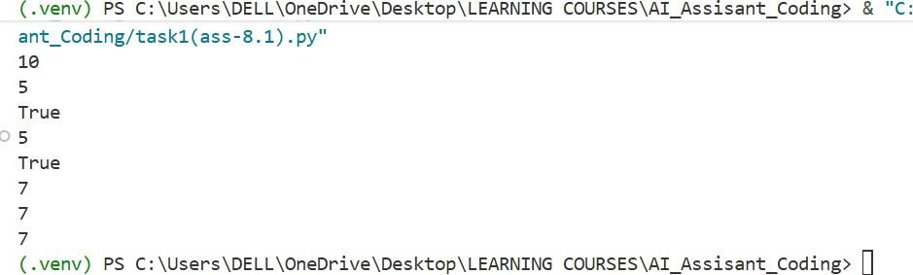

- Assert testing and Output:
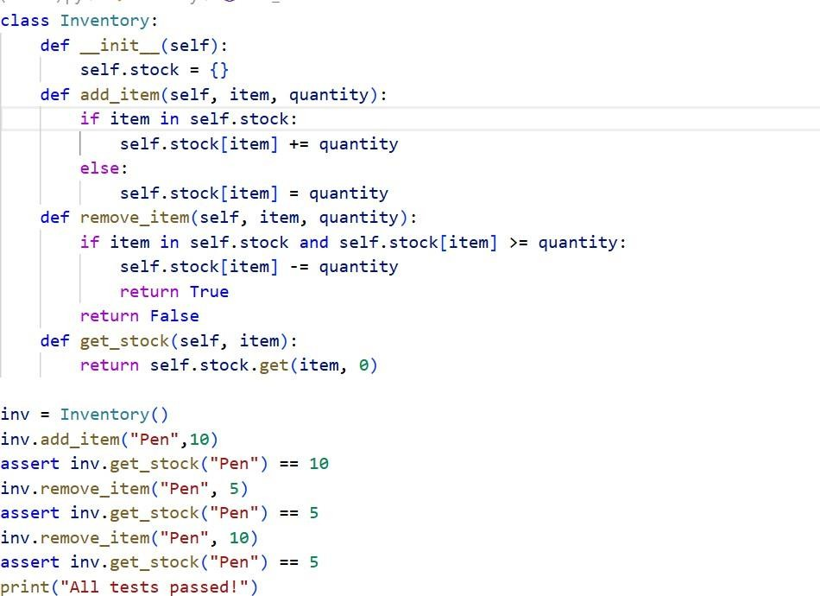

- Unit testing and Output:
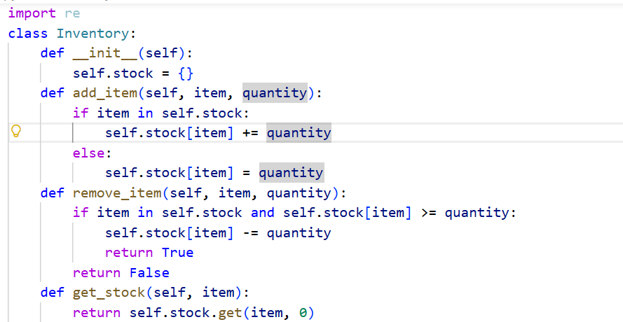

Create Next python file to run Test Cases:
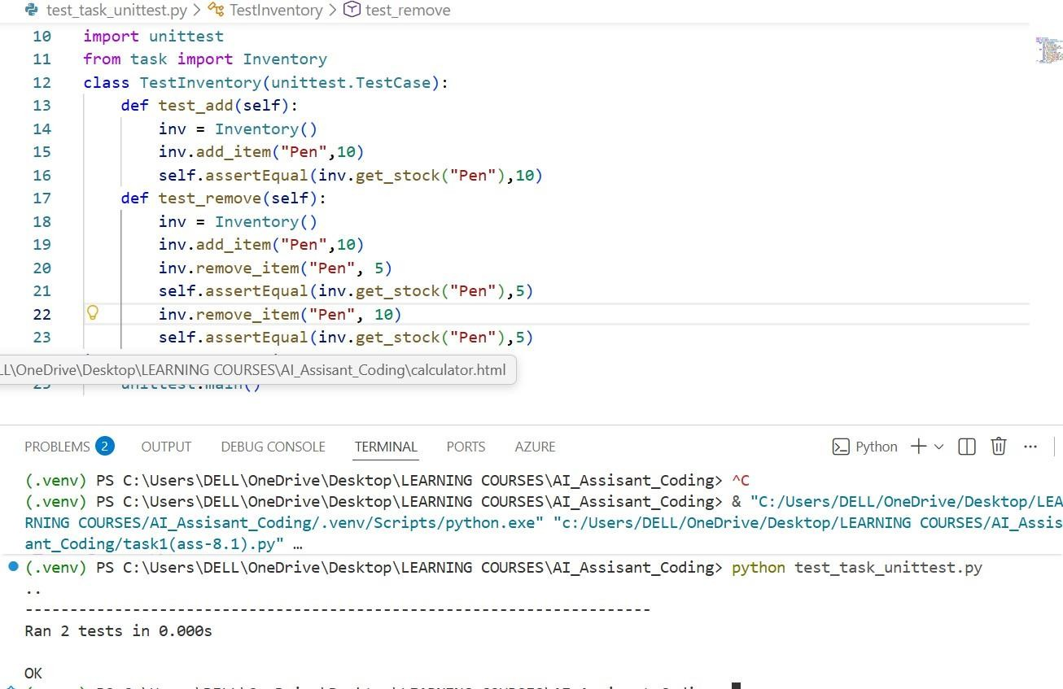

- Pytest and Output:
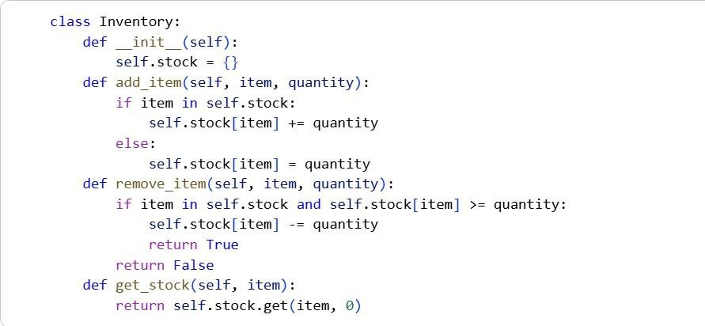
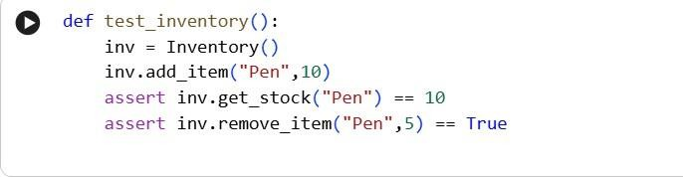

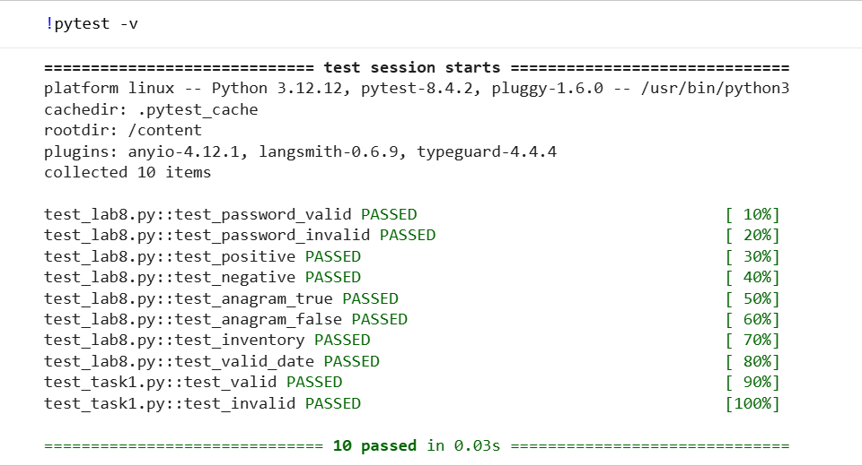
Justification:

This task simulates a real-world system.
  - AI generates realistic stock management tests.
  - Encourages object-oriented design.
  - Validates state updates inside a class.
  - Demonstrates data storage using dictionaries.
→ Applies OOP concepts
→ Simulates real inventory system
→ Encourages state validation

Task Description 5 (Date Validation & Formatting – Apply AI for Data Validation)
- Task: Use AI to generate at least 3 assert test cases for validate_and_format_date(date_str) to check and convert dates.
Prompt:

Generate at least 3 assert test cases for a function validate_and_format_date(date_str) that:

  - Validates "MM/DD/YYYY" format
  - Handles invalid dates
  - Converts valid dates to "YYYY-MM-DD"
Then implement the function so all test cases pass.

- General Testing and Output:
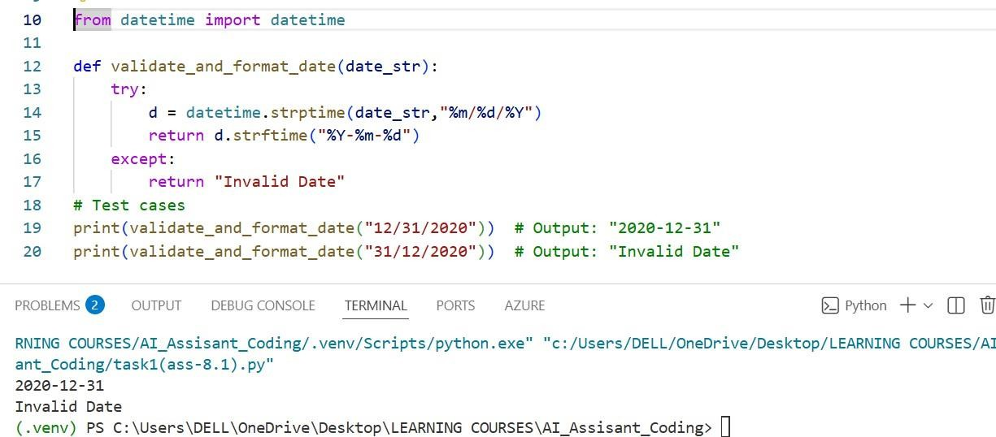

- Assert testing and Output:
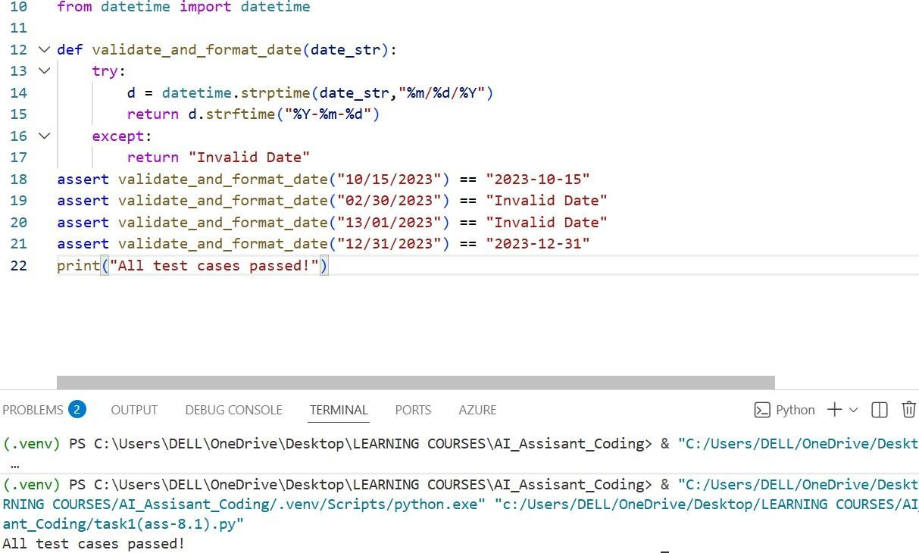

- Unit testing
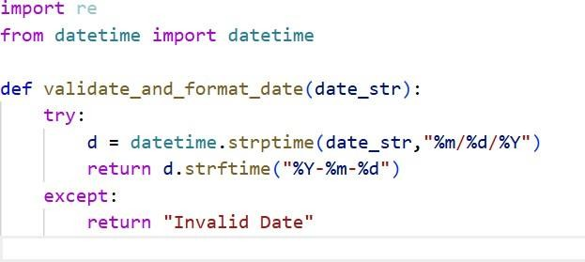

Create Next python file to run Test Cases:
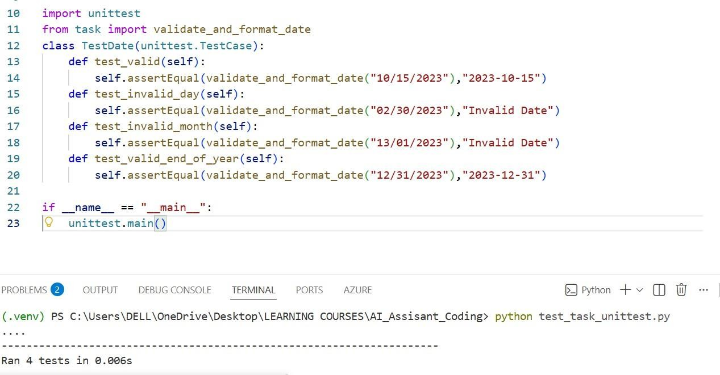
- Pytest and Output:

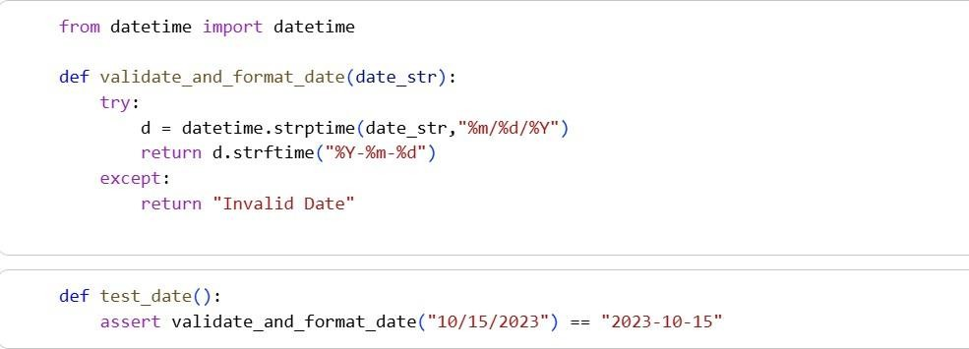
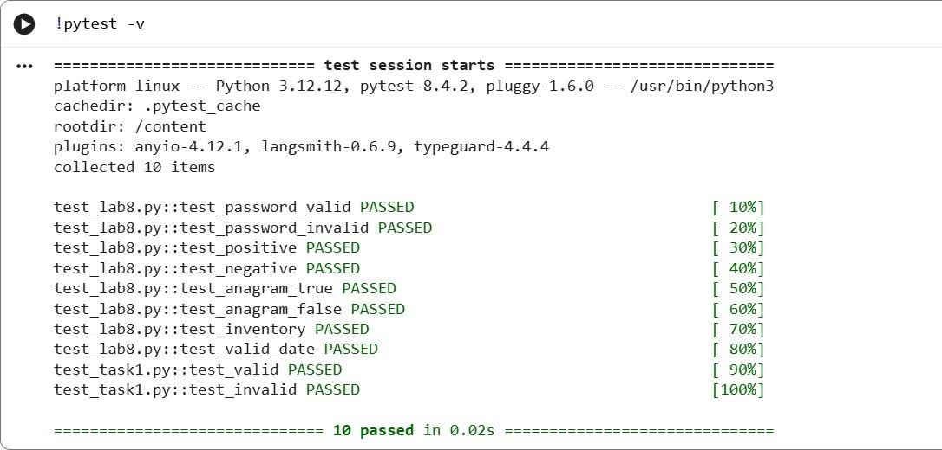

Justification:

This task focuses on data validation.
  - AI generates invalid date cases (e.g., Feb 30).
  - Ensures strict format validation.
  - Demonstrates exception handling.
  - Converts data into standardized format.
→ Reinforces error handling
→ Demonstrates datetime usage
→ Encourages clean data formatting

